Part 1

Using the techniques discussed in class. Prove each problem by using some or all of the cards mentioned in the problem. Complete a two-column proof for each exercise, with statements and reasons in the columns. A reason is needed for each statement. The final statement will be the item being proved.

Example:
Given: Yellow 4

In your hand you have Red 4, Blue Draw 2, Blue Skip, Green Skip and Green 4.

Prove: Blue Draw 2

Statement | Reason
Yellow 4 | Given
Green 4 | Same Number
Green Skip | Same Color
Blue Skip | Same Symbol
Blue Draw 2 | Same Color

All cards could have been played with an additional step by starting the proof with the Red 4.

- Given: Green Draw 2

In your hand you have Yellow 8, Blue 6, Red Skip and Green Skip.

Prove: Red 4

Statement | Reason

- Given: Red Draw 2

In your hand you have Red 8, Yellow 9, Green 9, Green 6, Blue 8, Blue Draw 2 and Red 4

Prove: Yellow 4

Statement | Reason

3) Given: Blue 6

You have in your hand Green Reverse, Blue Reverse and a Wild Card.

Prove: Red 7

Statement | Reason

4) Given: Yellow Draw 2

In your hand you have Green 6, Red 6, Red Reverse, Red Draw 2 and Yellow 6.

Prove: Green 7

Statement | Reason

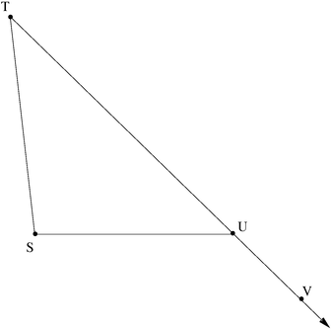
Part 2

Given: T = 30

VUS = 135

Prove: S = 105

Statement | Reason

