Part 1

Using the techniques discussed in class. Prove each problem by using some or all of the cards mentioned in the problem. Complete a two-column proof for each exercise, with statements and reasons in the columns. A reason is needed for each statement. The final statement will be the item being proved.

Example:
Given: Yellow 4

In your hand you have Red 4, Blue Draw 2, Blue Skip, Green Skip and Green 4.

Prove: Blue Draw 2

Statement | Reason
Yellow 4 | Given
Green 4 | Same Number
Green Skip | Same Color
Blue Skip | Same Symbol
Blue Draw 2 | Same Color

All cards could have been played with an additional step by starting the proof with the Red 4.

- Given: Green Draw 2

In your hand you have Yellow 8, Blue 6, Red Skip and Green Skip.

Prove: Red 4

Statement | Reason
Green Draw 2 | Given
Green Skip | Same Color
Red Skip | Same Symbol
Red 4 | Same Color

- Given: Red Draw 2

In your hand you have Red 8, Yellow 9, Green 9, Green 6, Blue 8, Blue Draw 2 and Red 4

Prove: Yellow 4

Statement | Reason
Red Draw 2 | Given
Red 8 | Same Color
Red 4 | Same Color
Yellow 4 | Same Number

3) Given: Blue 6

You have in your hand Green Reverse, Blue Reverse and a Wild Card.

Prove: Red 7

Statement | Reason
Blue 6 | Given
Blue Reverse | Same Color
Green Reverse | Same Symbol
Wild Card | Change Color
Red 7 | Same Color

4) Given: Yellow Draw 2

In your hand you have Green 6, Red 6, Red Reverse, Red Draw 2 and Yellow 6.

Prove: Green 7

Statement | Reason
Yellow Draw 2 | Given
Red Draw 2 | Same Symbol
Red 6 | Same Color
Green 6 | Same Number
Green 7 | Same Color

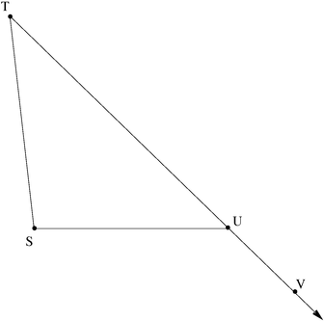
Part 2

Given: T = 30

VUS = 135

Prove: S = 105

Statement | Reason
T = 30 | Given
VUS = 135 | Given
TUS = 45 | Supplementary angles
T + TUS + S = 180 | Sum of the measures of the angles of a triangle is 180.
30 + 45 + S = 180 | Substitution
S = 105 | Addition Property of Equality (Subtract 75° from each side)

