Name: ________________________________ Period: ____________ Date: ______________
Thanksgiving Color Match Activity CONGRUENCE IN OVERLAPPING TRIANGLES
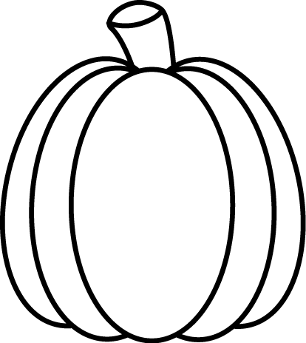
$$SR$$
$$SR$$
Congruent
$$5$$
$$7$$
$$11$$
$$C$$

Directions: Answer the questions. Find your answer on the Thanks-Giving Pumpkin. Then color according to your answers.
1. The common angle in the triangles below is angle ___________. (ORANGE)
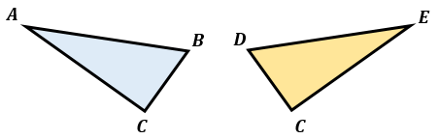
2. What is the length of the common side in the triangles below? (RED)
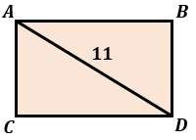
3. If the two triangles below are congruent, what is the value of $x$? (ORANGE)
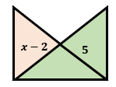
4. What is the value of $a$ in the figure given below? (RED)
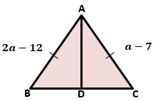
5. If RTS $≅$ PTS and PT $≅$ TR, then the two triangles below are _________. (GREEN)

6. If the two triangles below are congruent, the length of segment $PQ$ is same as ________. (GREEN)
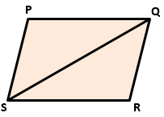

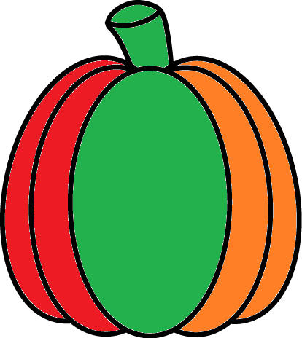 | Answers:  - ∠$C$  - $11$  - $7$  - $5$  - Congruent  - $SR$

