Name: ________________________________ Period: ____________ Date: ______________
Thanksgiving Color Match Activity CONGRUENCE IN RIGHT TRIANGLES
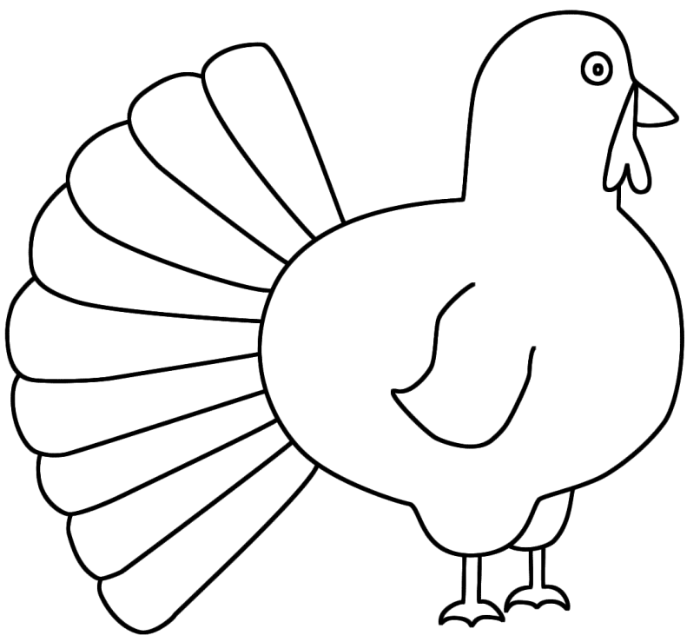
$$11$$
$$4$$
$$4$$
$$1$$
$$11$$
$$11$$
$$15°$$
$$1$$
$$70°$$
Leg-Leg
Leg-Leg
Leg-Leg
Leg-Leg
Leg-Leg
$$11$$
$$45°$$
$$10$$
Congruent
Size

Directions: Answer the questions. Find your answer on the Thanks-Giving Turkey. Then color according to your answers.
1. Two triangles are congruent if they have same shape and _________. (ORANGE)
2. If the hypotenuse and leg of one right triangle is congruent to the hypotenuse and corresponding leg of another triangle, the two triangles are ____________. (RED)
3. What is the value of $x$ in the figure given below? (PURPLE)
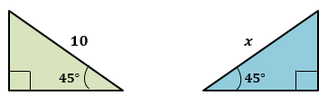
4. What is the value of $y$ in the figure given below? (YELLOW)
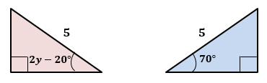
5. What is the value of $a$ in the figure given below? (BROWN)
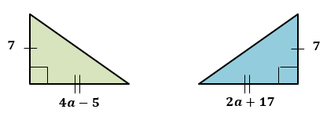
6. If the legs of one right triangle are congruent to the corresponding legs of another triangle, the two triangles are congruent by ____________ postulate. (PINK)

7. What is the value of $b$ in the figure given below? (GREEN)
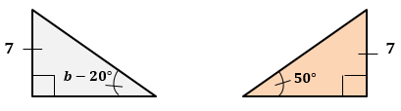
8. What is the value of $x$ in the figure given below? (SKY BLUE)
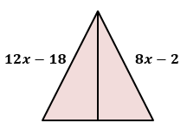
9. What is the value of $y$ in the figure given below? (LIGHT GREEN)
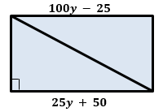
10. What is the value of $z$ in the figure given below? (GREY)
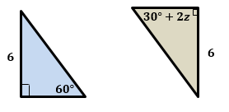

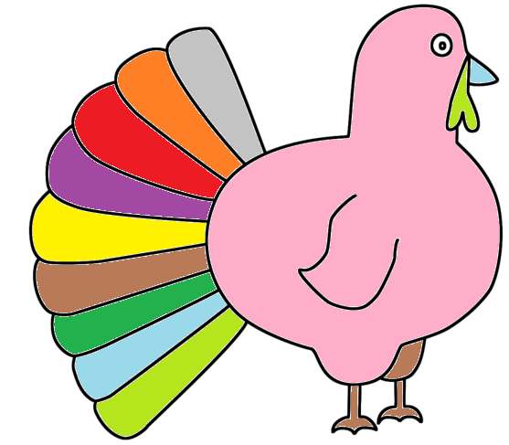 | Answers:  - Size  - Congruent  - $10$  - $45°$  - $11$  - Leg-Leg  - $70°$  - $4$  - $1$  - $15°$

