Name: ________________________________ Period: ____________ Date: ______________  
**Thanksgiving Color Match Activity** ISOSCELES AND EQUILATERAL TRIANGLES

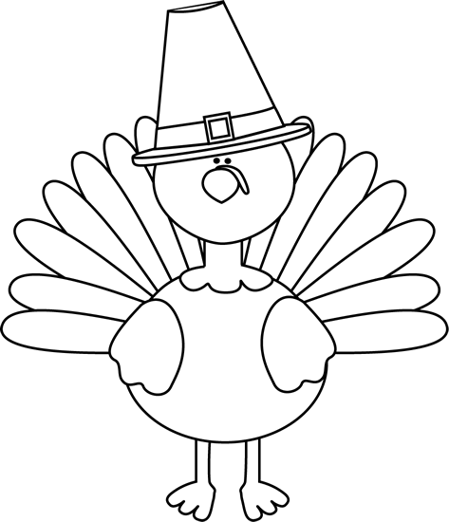

$$40°$$

$$40°$$

$$40°$$

$$40°$$

$$40°$$

$$40°$$

$$5 cm$$

**Equilateral**

**Equilateral**

**Base**

**Base**

**Legs**

**Legs**

$$5 cm$$

$$5 cm$$

$$5 cm$$

**Equilateral**

**Equilateral**

$$13 cm$$

**Legs**

**Legs**

$$40°$$

$$40°$$

**Congruent**

**Base**

**Base**

**Isosceles**

**Directions: Answer the questions. Find your answer on the Thanks-Giving Turkey. Then color according to your answers.**

**1.** A triangle having two congruent sides is known as an _____________ triangle. **(ORANGE)  
  
2.** The non-congruent side of an isosceles triangle is known as _________. **(LIGHT GREEN)  
   
3.** If the two sides of a triangle are congruent, then the corresponding base angles are ________. **(PINK)  
   
4.** What is the value of **∠**A in the triangle given below? **(YELLOW)   
 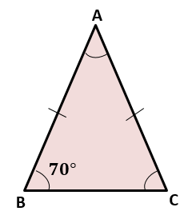**

**5.** If the two base angles of a triangle are congruent, then the two ______ of the triangle are also congruent. **(BLUE)**

**6.** What is the value of $AC$ in the triangle shown below? **(PINK)**

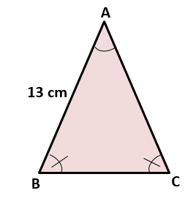

**7.** A triangle having all three sides congruent is known an ___________ triangle. **(RED)**

**8.** What will be the value of $DF$ in the triangle below if the triangle is an equilateral triangle? **(SKY BLUE)**

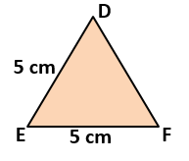

|  |  |
| --- | --- |
|  | **Answers:**   1. **Isosceles** 2. **Base** 3. **Congruent** 4. **Legs** 5. **Equilateral** |