Name: ________________________________ Period: ____________ Date: ______________
Thanksgiving Color Match Activity USING CPCTC
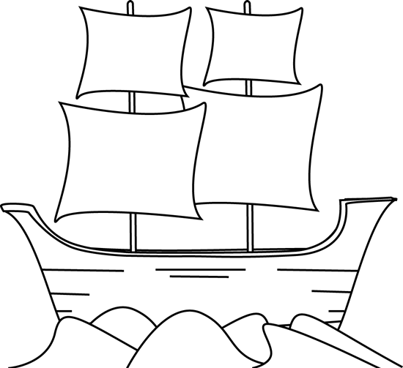
ASA
Size
$$30°$$
$$30°$$
$$45°$$
$$x=1, y=1$$
$$42°$$
$$42°$$
$$42°$$
$$42°$$
$$90°$$
$$30°$$
$$45°$$
Congruent

Directions: Answer the questions. Find your answer on the May-Flower ship. Then color according to your answers.
1. Two triangles are congruent if they have the same shape and the same ______. (YELLOW)
2. The triangles in below figure are congruent by _______ postulate. (ORANGE)
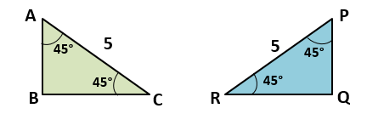
3. The corresponding parts of congruent triangles are ______________. (PINK)
4. What is the value of ∠R if the two triangles given below are congruent? (LIGHT BLUE)
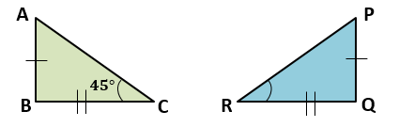
5. What is the value of $x$ if the two triangles given below are congruent? (GREY)
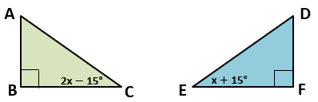
6. What is the value of ∠B in the figure shown above? (SKY BLUE)

7. What is the value of $y$ in the figure shown below? (BROWN)
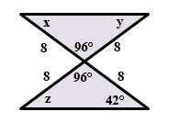
8. What will be the value of $x$and $y$ if both right triangles are congruent? (GREEN)
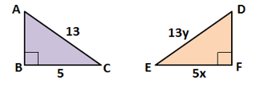

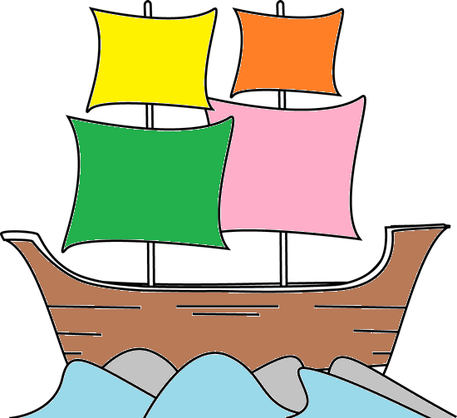 | Answers:  - Size  - ASA  - Congruent  - $45°$  - $30°$  - $90°$  - $42°$  - $x=1,y=1$

