Name: ________________________________ Period: ____________ Date: ______________  
**Thanksgiving Color Match Activity** TRIANGLE CONGRUENCE BY ASA AND AAS



$$x=1, y=1$$

$$x=1, y=1$$

$$15°$$

$$15°$$

$$15°$$

**HL**

**Right**

**AAS**

**ASA**

**Congruent**

**Size**

**Directions: Answer the questions. Find your answer on the Thanks-Giving Pumpkin Pie. Then color according to your answers.**

**1.** Two triangles are congruent if they have the same shape and the same ______. **(PINK)  
  
  
  
  
2.** If the two angles and their included side of one triangle is congruent to the two angles and their included side of another triangle, then the two triangles are said to be ___________**.** **(RED)**

**3.** The triangles in below figure are congruent by _______ postulate. **(YELLOW)  
   
 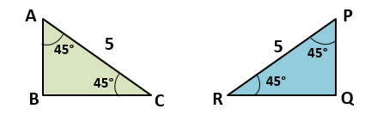  
  
4.** The triangles in figure below are congruent by __________ postulate. **(ORANGE)  
  
 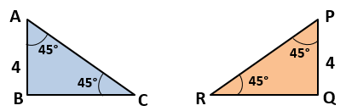**

**5.** The hypotenuse-leg postulate applies to the ________ triangles. **(PURPLE)**

**6.** The triangles in figure below are congruent by __________ postulate. **(GREEN)**

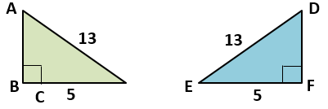

**7.** What will be the value of $x$ if two triangles are congruent? **(GREY)**

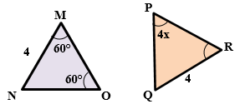

**8**. What will be the value of $x$ and $y$ if both right triangles are congruent? **(LIGHT GREEN)**

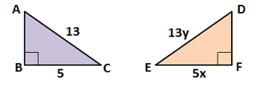

|  |  |
| --- | --- |
|  | **Answers:**   1. **Size** 2. **Congruent** 3. **ASA** 4. **AAS** 5. **Right** 6. **HL** |