Name: ________________________________ Period: ____________ Date: ______________  
**Thanksgiving Color Match Activity** TRIANGLE CONGRUENCE BY SSS AND SAS

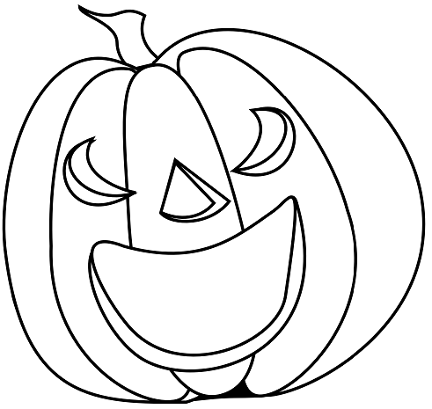

$$3$$

$$3$$

$$3$$

$$3$$

$$4$$

**Equal**

$$20°$$

**Congruent**

**SSS**

**SAS**

$$4$$

**SAS**

**SSS**

**Congruent**

$$108°$$

**Size**

**Directions: Answer the questions. Find your answer on the Thanks-Giving Pumpkin. Then color according to your answers.**

**1.** Two triangles are congruent if they have the same shape and the same ______. **(ORANGE)  
  
  
  
  
2.** In the figure given below, what is the value of angle $y?$**(ORANGE)**

**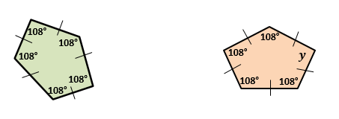   
3.** If all the three sides of one triangle are congruent (equal in measures) to all the corresponding three sides of another triangle, then the two triangles are said to be __________. **(YELLOW)  
  
  
  
  
4.** The two triangles shown in below figure are congruent by _______ postulate. **(ORANGE)  
   
 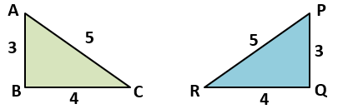  
  
  
5.** The triangles in figure below are congruent by __________ postulate. **(ORANGE)  
  
 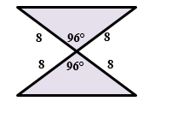**

**6.** What will be the value of $x$ if $∆$ ABC $≅$ $∆$ DEF? **(SKY BLUE)**

**E**

**D**

**A**

$$2x$$

**8**

**8**

**F**

**B**

**C**

**7.** What will be the value of $r$ if $∆$ ABC $≅$ $∆$ DEF? **(GREEN)**

**A**

**D**

**E**

**60°**

**10**

**10**

$$3r$$

**C**

**B**

**F**

**8.** The corresponding sides of the congruent shapes are ___________. **(ORANGE)**

**9.** An equilateral triangle has ________ congruent sides. **(YELLOW)**

|  |  |
| --- | --- |
|  | **Answers:**   1. **Size** 2. **Congruent** 3. **SSS** 4. **SAS** 5. **Equal** |