Name: ________________________________ Period: ____________ Date: ______________  
**Thanksgiving Color Match Activity** CONGRUENT FIGURES  
  
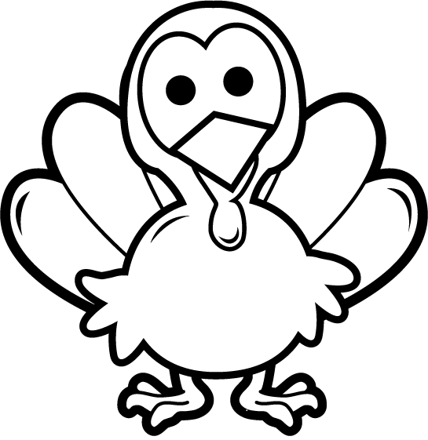

**2-dimensional**

$$108°$$

$$108°$$

**Equal**

**Congruent**

$$6 cm$$

**Ratios**

$$45°$$

**Similar**

**Angle**

**2-dimensional**

**2-dimensional**

**2-dimensional**

**Directions: Answer the questions. Find your answer on the Thanks-Giving Turkey. Then color according to your answers.**

**1.** The figure below represents a ________________ figure. **(LIGHT YELLOW)**

**2.** The __________ refers to the measure of turn between two line segments. **(RED)  
   
  
  
  
3.** If the two figures have same shape but not the same size, the figures are __________. **(ORANGE)  
  
  
  
  
4.** If the figures below are similar, what is the measure of angle A? **(YELLOW)  
   
  
  
  
  
  
  
  
5.** The corresponding sides of the similar shapes have same _________. **(GREY)  
  
  
  
  
6.** In the figure given below, what is the value of $x?$ **(RED)   
  
 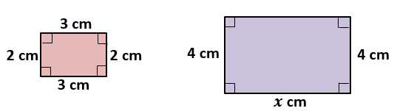**

$$A$$

$$45°$$

**7.** If the two figures have same shape and size, the figures are __________. **(ORANGE)**

**8.** The corresponding sides of the congruent shapes are ___________. **(GREEN)**

**9.** In the figure given below, what is the value of angle $y?$**(BROWN)**

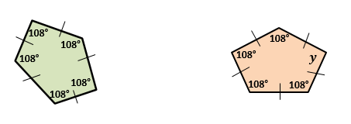

|  |  |
| --- | --- |
|  | **Answers:**   1. **2-dimensional** 2. **Angle** 3. **Similar** 4. **Ratios** 5. **Congruent** 6. **Equal** |