Name: ________________________________ Period: ____________ Date: ______________  
**Halloween Color Match Activity** PROVE THEOREMS ABOUT PERPENDICULAR LINES  
  
  


**Line**

**Line**

$$24$$

$$24$$

$$24$$

$$24$$

$$FS$$

$$FS$$

**Line**

**Parallel**

**Parallel**

**Parallel**

**Parallel**

$$\overset{⃡}{t}⊥\overset{⃡}{m}$$

**Complementary**

$$90°$$

**Perpendicular**

**Directions: Answer the questions. Find your answer on the Halloween Jack O-Lantern. Then color according to your answers.**

**1.** If two lines intersect to form a linear pair of congruent angles, then the lines are ________. **(RED)**

**2.** If two lines are perpendicular, then they intersect each other at angle of _________. **(ORANGE)  
   
  
  
  
3.** In the figure below, if $\overset{⃡}{OP}⊥\overset{⃡}{OR}$ then $∠1$ and $∠2$ are ____________. **(YELLOW)  
  
 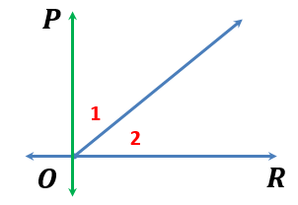  
  
  
4.** In the figure below, if $\overset{⃡}{l}∥ \overset{⃡}{m}$ and $\overset{⃡}{t}⊥\overset{⃡}{l},$ then___________. **(LIGHT YELLOW)  
   
 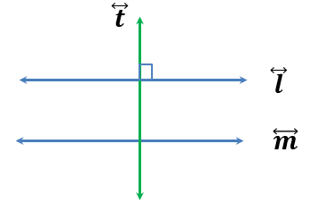  
  
  
5.** In a plane, if two lines are perpendicular to the same line, then they are _________ to each   
other. **(ORANGE)  
  
  
  
6.** This perpendicular segment is the shortest distance between the point and the _______. **(RED)   
  
  
  
7.** In the figure given below, which segment represents the shortest distance between the point F and   
the line? **(GREEN)** 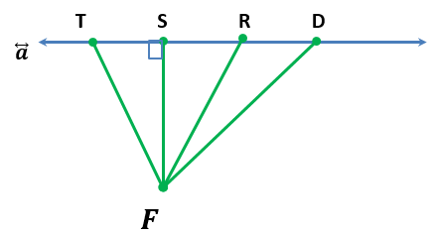

**8.** In the figure given below, what is the value of $x?$**(ORANGE)**

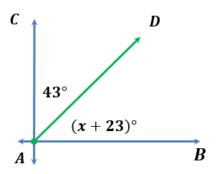

|  |  |
| --- | --- |
|  | **Answers:**   1. **Perpendicular** 2. **Complementary** 3. **Parallel** 4. **Line** |