Name: ________________________________ Period: ____________ Date: ______________
Color Match Activity PROVE LINES PARALLEL
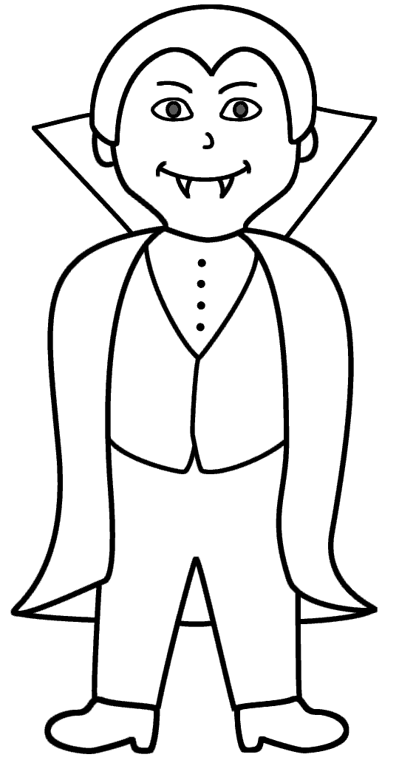
$$∠3≅∠6$$
Parallel
$$180°$$
$$180°$$
$$50°$$
$$50°$$
$$50°$$
$$60°$$
$$60°$$
$$70°$$
$$50°$$
$$50°$$
Congruent
$$∠2≅∠7$$
$$∠2≅∠7$$

$$60°$$

Directions: Answer the questions. Find your answer on the Halloween Vampire. Then color according to your answers.
1. If two lines and a transversal form alternate interior angles that are congruent, then the two lines are _____________. (BLACK)
2. In the figure given below, the two lines are parallel if ______________. (GREY)
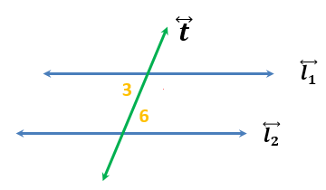
3. In the figure given below, what is the value of angle $x?$ (BLACK)
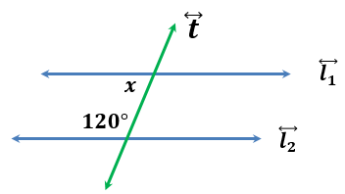
4. In the figure given below, the two lines are parallel if ______________. (RED)
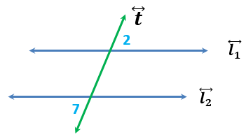
5. If a transversal intersects two parallel lines, then corresponding angles are _________. (PURPLE)

6. In the figure given below, what is the value of $x$ so that$\overset{⃡}{s} ∥ \overset{⃡}{p} ?$ (BLACK)
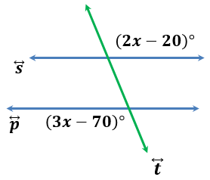
7. In the figure given below, what is the value of $y$ so that $\overset{⃡}{a} ∥ b ?$ (LIGHT YELLOW)
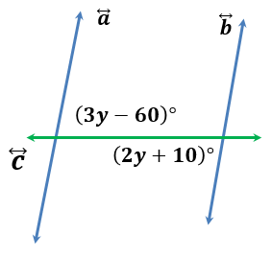
8. In the figure below, the sum of <3 and <5 is ______________. (GREEN)
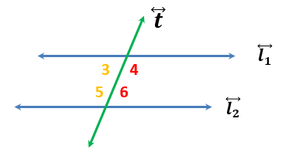

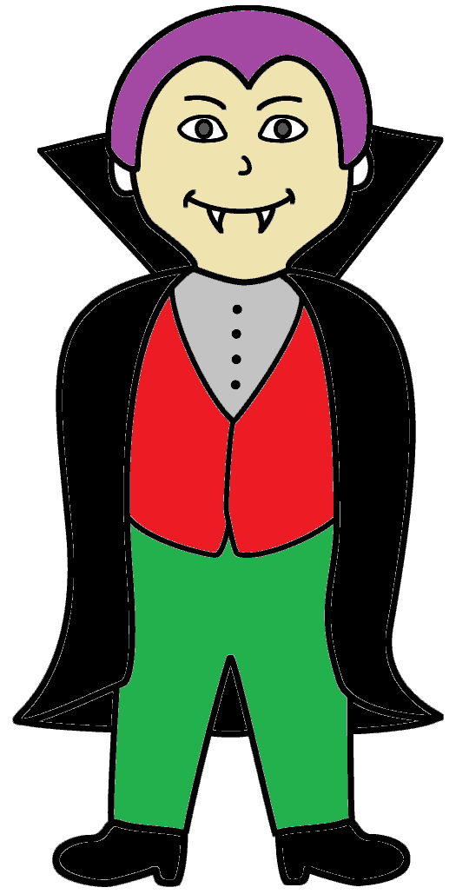 | Answers:  - Parallel  - $∠3≅∠6$  - $60°$  - $∠2≅∠7$  - Congruent  - $50°$  - $70°$  - $180°$

