Name: ________________________________ Period: ____________ Date: ______________
Color Match Activity USE PARALLEL LINES AND TRANSVERSALS
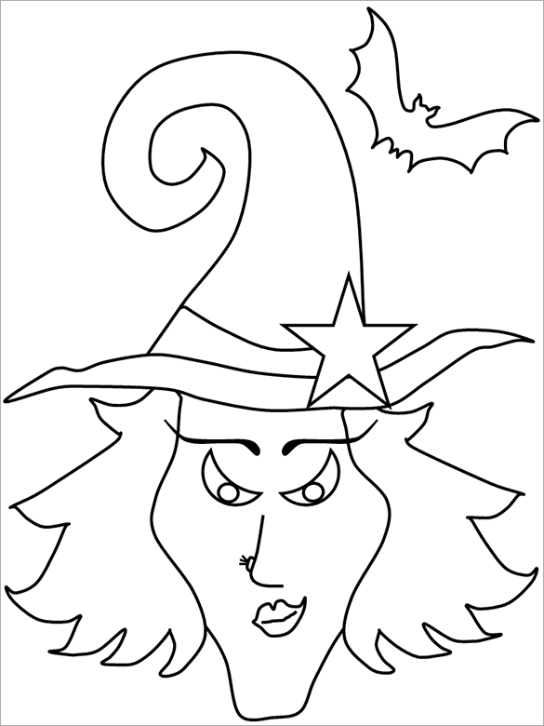
$$30°$$
Congruent
$$180°$$
$$180°$$
$$180°$$
$$180°$$
$$45°$$
$$45°$$
Alternate Exterior
$$45°$$
$$110°$$
$$120°$$
Transversal
Directions: Answer the questions. Find your answer on the Halloween Witch. Then color according to your answers.
1. A line that intersects two or more coplanar lines at distinct points is a ____________. (YELLOW)
2. What is the value of angle $x$ in the figure given below? (GREEN)
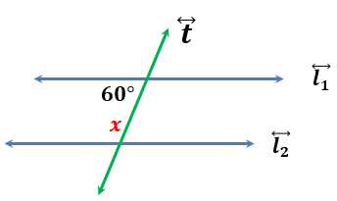
3. If a transversal intersects two parallel lines, then corresponding angles are _________. (ORANGE)
4. What is the value of angle $y$ in the figure given below? (BLACK)
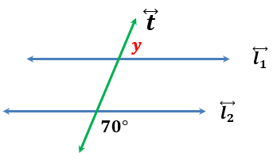
5. In the figure below, what is the value of angle $x$? (BLACK)
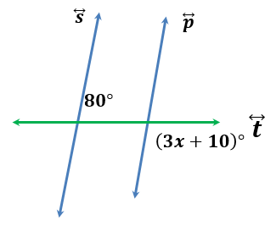

6. In the figure given below, what is the value of angle $z$?. (RED)
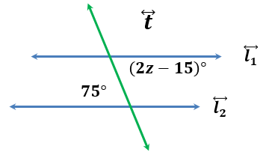
7. In the figure given below, <y and <z are ____________________ angles. (YELLOW)
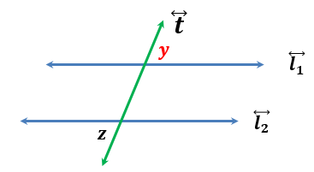
8. In the figure below, the sum of <3 and <5 is ______________. (LIGHT YELLOW)
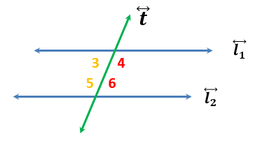

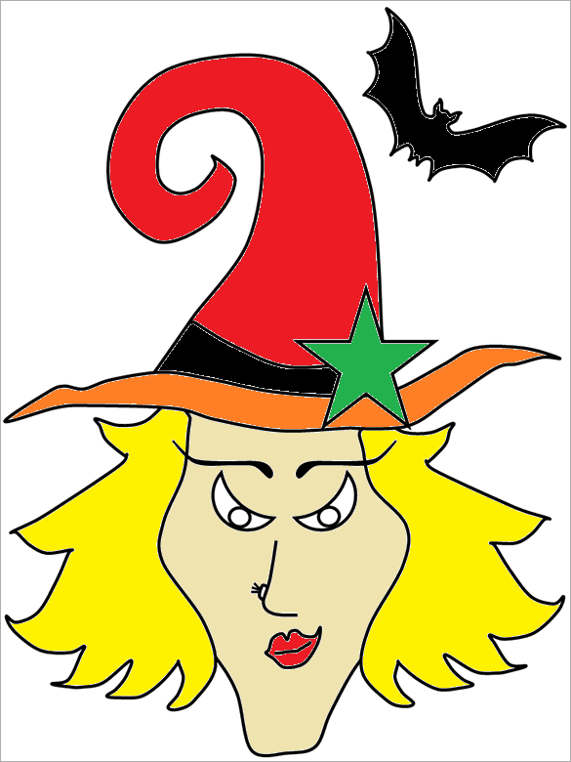 | Answers:  - Transversal  - $120°$  - Congruent  - $110°$  - $30°$  - $45°$  - Alternate Exterior  - $180°$

