Name: ________________________________ Period: ____________ Date: ______________
Color Match Activity IDENTIFY PAIRS OF LINES AND ANGLES
Parallel
$$90°$$
$$180°$$
$$180°$$
$$180°$$
Congruent
Corresponding
Alternate
Congruent
$$180°$$
$$90°$$

Directions: Answer the questions. Find your answer on the Halloween Jack-O-Lantern. Then color according to your answers.
1. If two lines never intersect each other, the lines are ___________. (GREEN)
2. Two lines are perpendicular if they meet each other at an angle of ___________. (BLACK)
3. Two angles are said to be supplementary if their sum is _________. (BLACK)
4. In the figure given below <A and <B are ________________. (ORANGE)
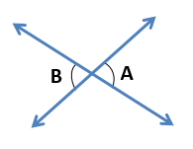
5. In the figure below, <B and <D are ______________ Exterior Angles. (ORANGE)
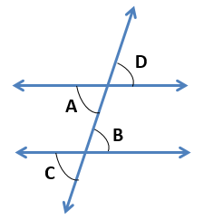
6. In the figure below, <A and <C are ____________ Angles. (ORANGE)
Answers:
- Parallel
- $90°$
- $180°$
- Congruent
- Alternate
- Corresponding

