Name: ________________________________ Period: ____________ Date: _______________
11-7 Areas and Volumes of Similar Solids – Pi-Day Color Match Activity SE

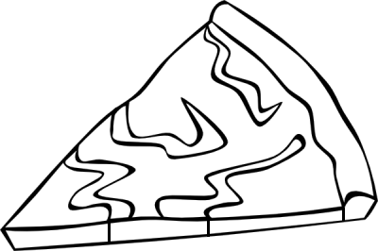
$$8$$
$$8$$
$$201.5$$
$$9:8$$
$$1:2$$
$$1:3$$
$$270$$
$$\frac{A_{1}}{A_{2}}=\frac{a^{2}}{b^{2}}$$
$$\frac{A_{1}}{A_{2}}=\frac{a^{2}}{b^{2}}$$
$$\frac{A_{1}}{A_{2}}=\frac{a^{2}}{b^{2}}$$
$$\frac{A_{1}}{A_{2}}=\frac{a^{2}}{b^{2}}$$
$$2$$
Scale
Similar

Directions: Answer the questions. Find your answer on the Pizza Pie. Then color according to your answers.
1. If the corresponding linear dimensions of two solids are proportional, the two solids are __________. (YELLOW)
2. For two solids to be similar, all of their corresponding linear dimensions must have the same _________ factor. (PINK)
3. The scale factor for the figures shown below is ___________. (LIGHT GREEN)
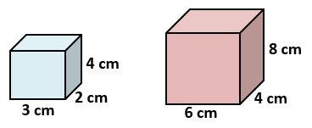
4. If the two solids have a similarity ratio $a :b$, then the ratio of their areas is mathematically as __________. (ORANGE)
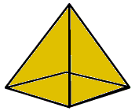
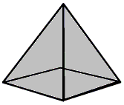
5. The two solids shown have a similarity ratio of 2 : 3. The surface area of the smaller solid is $120 {cm}^{2}$. The area of the larger solid is ___________ ${cm}^{2}$. (BLUE)

6. The similarity ratio for the figures given below is ___________$.$ (RED)
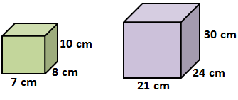
7. The similarity ratio for the figures given below is ___________$.$ (BROWN)
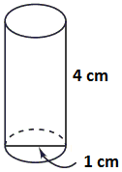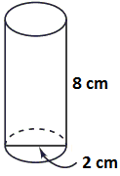
8. Two similar figures have areas $81 m^{2}$ and $64 m^{2}$. The similarity ratio is ________. (GREEN)

9. The surface areas of two similar solids are $144 cm^{2}$ and $196 cm^{2}$. The volume of the larger solid is $320 cm^{3}$. The volume of the smaller solid is __________ $cm^{3}$. (GREY)
10. If the similarity ratio of the two similar figures is doubled, the ratio of their volumes is increased by $_____________$ times. (PURPLE)

