Name: ________________________________ Period: ____________ Date: __________________
11-6 Surface Areas and Volumes of Spheres – Pi-Day Color Match Activity SE

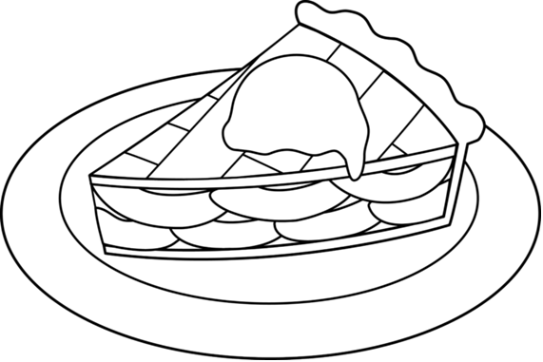
$$92$$
$$92$$
$$4.9$$
$$4.9$$
$$V=\frac{4}{3}πr^{3}$$
$$V=\frac{4}{3}πr^{3}$$
$$4.9$$
$$4.9$$
$$4.9$$
$$4.9$$
$$4.9$$
$$4.9$$
$$4.9$$
$$314$$
$$314$$
$$50.24$$
$$50.24$$
$$2143$$
$$V=\frac{4}{3}πr^{3}$$
$$V=\frac{4}{3}πr^{3}$$
$$201$$
$$201$$
$$201$$
$$201$$
$$201$$
$$201$$
$$201$$
$$A=4πr^{2}$$
$$A=4πr^{2}$$
$$A=4πr^{2}$$
Radius
Sphere
Sphere

Directions: Answer the questions. Find your answer on the Apple Pie. Then color according to your answers.
1. A set of all points in space that are a fixed distance from a fixed point represent a ___________. (YELLOW)
2. The distance between the center of the sphere and any fixed point on the sphere is known as the __________ of the sphere. (RED)
3. The surface area of the sphere is written mathematically as ___________. (LIGHT GREEN)
4. The surface area of the sphere with diameter $8 cm$ is _____________ $cm^{2}$. (ORANGE)
5. The volume of the sphere is written mathematically as ___________. (BROWN)
6. The volume of the sphere with radius $8 in$ is __________${in}^{3}.$ (GREEN)
7. The surface area of the sphere shown below is _________ ${cm}^{2}$. (PINK)
8. The volume of the pyramid given below is ___________ $m^{3}$. (LIGHT BLUE)
9. The radius of a sphere with surface area $300 cm^{2}$ will be ___________ $cm$. (LIGHT GREEN)
10. The volume of a sphere with surface area $101.34 m^{2}$ is ____________ $m^{3}$. (PURPLE)

