Name: ________________________________ Period: ____________ Date: ________________
11-5 Volumes of Pyramids and Cones – Pi-Day Color Match Activity SE

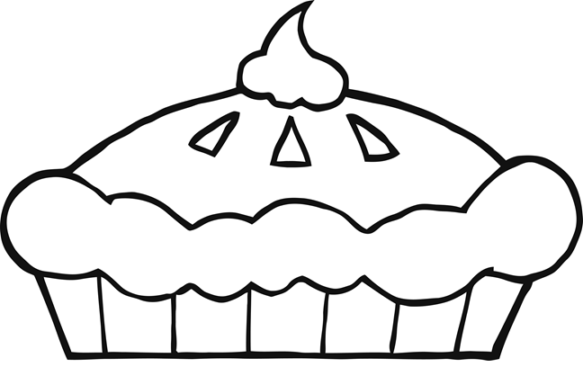
$$6.2$$
$$202$$
$$202$$
$$202$$
$$6.2$$
$$6.2$$
$$6.2$$
$$309.3$$
Rectangular
$$120$$
$$134$$
$$400$$
$$V=\frac{1}{3}×A×h$$
Cone
Pyramid

Directions: Answer the questions. Find your answer on the Pie. Then color according to your answers.
1. A polyhedron whose base is any polygon and the lateral faces are triangles meeting at a vertex is known as a _____________. (ORANGE)
2. The figure shown below is a _____________ pyramid. (GREEN)
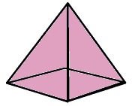
3. The figure shown below represents a/an ___________. (BLUE)
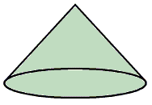
4. The volume of a pyramid is written mathematically as _____________. (YELLOW)
5. The volume of the pyramid given below is ___________ $cm^{3}$. (RED)
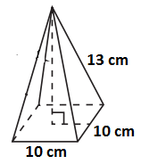
6. The volume of the cone given below is __________$m^{3}.$ (BROWN)
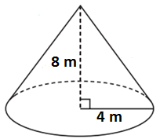
7. The volume of the pyramid shown below is _________ ${cm}^{3}$. (PURPLE)
8. The volume of the pyramid given below is ___________ $m^{3}$. (PINK)
9. The volume of the cone given below is _________ $m^{3}.$ (LIGHT GREEN)
10. The volume of the cone given below is _________ ${mm}^{3}.$ (ORANGE)

