Name: ________________________________ Period: ____________ Date: ________________
11-4 Volumes of Prisms and Cylinders – Pi-Day Color Match Activity SE
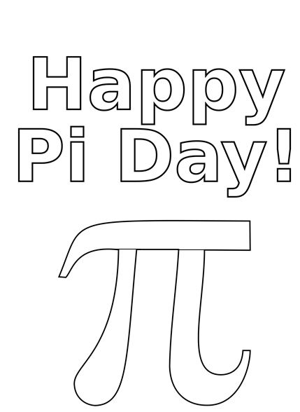
$$640$$
$$640$$
$$72$$
$$72$$
$$72$$
$$40$$
$$40$$
$$40$$
$$40$$
$$32$$
$$32$$
$$32$$
$$840$$
$$840$$
$$840$$
Volume
Cylinder
$$A=πr^{2}$$
Bases
Pentagonal

Directions: Answer the questions. Find your answer on the Pi-Day Symbol. Then color according to your answers.
1. A prism is a polyhedron with two congruent parallel faces called __________. (ORANGE)
2. The figure shown below is a _____________ prism. (GREEN)
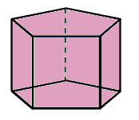
3. The product of the area of the base and height of the prism gives the _________ of a prism. (BLUE)
4. The figure shown below represents a ____________. (YELLOW)
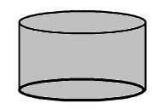
5. The area of a circle is mathematically written as __________. (LIGHT BLUE)
6. The volume of the prism given below is __________$m^{3}.$ (GREY)
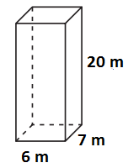

7. The volume of the cylinder shown below is _________$π$ ${cm}^{3}$. (BROWN)
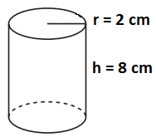
8. The volume of the prism given below is ___________ ${in}^{3}$. (PINK)
9. The volume of the prism given below is _________ $cm^{3}.$ (RED)
10. The volume of the cylinder given below is _________$π$ ${cm}^{3}.$ (LIGHT GREEN)

