Name: ________________________________ Period: ____________ Date: ________________
11-3 Surface Areas of Pyramids and Cones – Pi-Day Color Match Activity SE
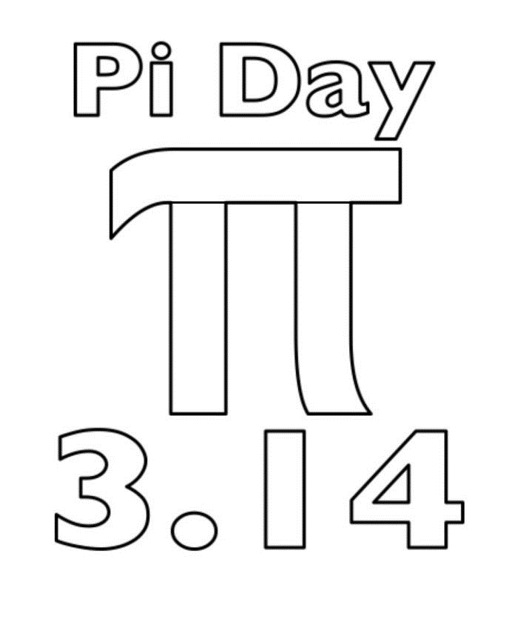
$$161$$
$$75$$
$$75$$
$$161$$
$$120$$
$$151$$
$$96$$
$$96$$
$$C=2πr$$
$$16$$
Cone
Hexagonal
Pyramid

Directions: Answer the questions. Find your answer on the Pi-Day Symbol. Then color according to your answers.
1. A polyhedron whose base is any polygon and the lateral faces are triangles meeting at a vertex is known as a _____________. (ORANGE)
2. The figure shown below is a _____________ pyramid. (GREEN)
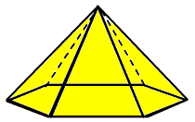
3. The figure shown below represents a/an ___________. (BLUE)
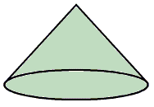
4. The lateral area of the pyramid in the figure shown below is ___________ ${cm}^{2}$. (YELLOW)
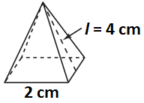
5. The circumference of the circle is mathematically written as __________. (LIGHT BLUE)
6. The surface area of the cone given below is _________ $π m^{2}.$ (GREY)
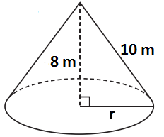
7. The lateral area of the cone given below is _________ ${cm}^{2}$. (BROWN)
8. The lateral area of the pyramid given below is ___________ $m^{2}$. (PINK)
9. The surface area of the pyramid given below is _________ $cm^{2}.$ (LIGHT GREEN)
10. The surface area of the cone given below is _________ $in^{2}.$ (PINK)

