Name: ________________________________ Period: ____________ Date: _________________
11-2 Surface Areas of Cylinders and Prisms – Pi-Day Color Match Activity SE

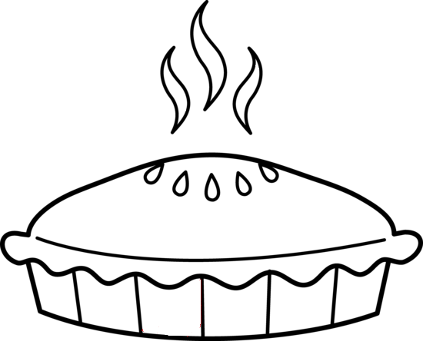
$$101$$
$$101$$
$$101$$
$$101$$
$$101$$
$$101$$
$$101$$
$$70$$
$$70$$
Cylinder
$$101$$
$$101$$
Hexagonal
$$300$$
$$40$$
$$604$$
Lateral
Prism

Directions: Answer the questions. Find your answer on the Pie. Then color according to your answers.
1. A polyhedron with two congruent parallel faces is known as _________. (RED)
2. The figure shown below is a _____________ prism. (PINK)
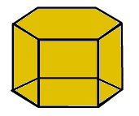
3. The product of the perimeter of the base and the height of the prism is known as _____________ area of the prism. (YELLOW)
4. The surface area of the prism in the figure shown below is ___________ $m^{2}$. (ORANGE)
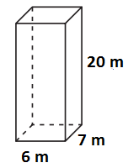
5. A prism with circular bases is known as a ___________. (GREEN)
6. The surface area of a cylinder having height $8 cm$ and radius $2 cm$ is _________ $π m^{2}.$ (GREY)
7. The lateral area of the prism given below is _________ ${cm}^{2}$. (PURPLE)
8. The surface area of the cylinder given below is ___________ $cm^{2}$. (LIGHT GREEN)
9. The lateral area of the prism given below is _________ $sq. in.$ (GREY)

