Name: ________________________________ Period: ____________ Date: ________________
11-1 Space Figures and Cross Sections – Pi-Day Color Match Activity SE
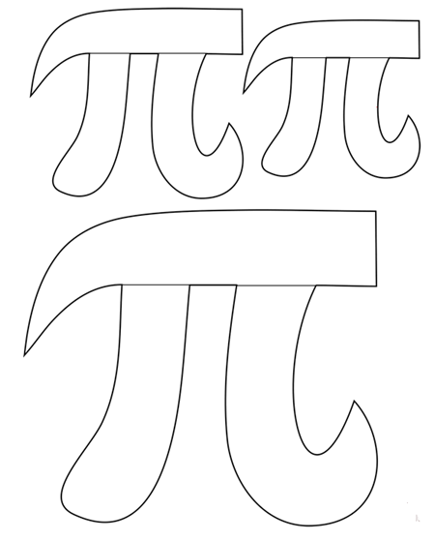
Circle
$$4$$
$$8$$
Ellipse
$$5$$
Vertex
Edge
Net
Polyhedron

Directions: Answer the questions. Find your answer on the Pi symbol. Then color according to your answers.
1. A 3-dimensional figure that is formed by polygons enclosing a region in space is known as a __________________. (RED)
2. The shape being formed if the polyhedron is opened up flat is known as __________ of a polyhedron. (PINK)
3. The line segment where two faces meet is known as the _______. (YELLOW)
4. The point of intersection of two edges is known as the ________. (ORANGE)
5. The number of faces of a polyhedron having 8 edges and 5 vertices is __________. (GREEN)
6. The cross section of the shape given below is a/an __________. (BROWN)
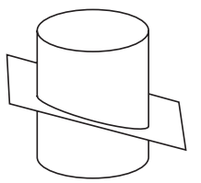
7. The number of edges of a polyhedron having 4 faces and 6 vertices is __________. (LIGHT BLUE)
8. The number of vertices of a polyhedron having 4 faces and 6 edges is __________. (PURPLE)
9. The cross section of the shape given below is a/an __________. (GREY)
