TRUE OR FALSE. If false, give a counterexample.

1) 2 isosceles triangles with congruent bases are congruent. ____________________

2) Every altitude bisects the segment it is drawn to. ________________________

3) If 2 equilateral triangles have the same perimeter, then they are congruent. ___________________

SECTION TWO – COMPUTATIONS

4) Give the relationship between segments BC and DC. (<, >, or =)

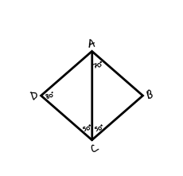

5) Given a triangle with perimeter of 18cm, give the side measures of 4 different isosceles triangles keeping in mind that each triangle must be possible.

6) Find <1, <2, and <3.

<1 = ________

<2 = ________

<3 = ________

7) Find the measures of <1, <2, and <3. Yes, there is enough information.

<1 = ________

<2 = ________

<3 = ________

8) In ▲DEF, DB=24.6, and EZ=11.6. Find each length.

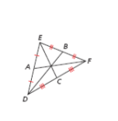

DZ=_______ ZB=_______ ZC=_______ EC=_______

9) PX, PY, and PZ are the perpendicular bisectors of ▲GHJ. Find each length.

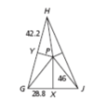

GY=_______ GP=_______ GJ=_______ PH=_______

10) UA and VA are angle bisectors of ▲UVW. Find each measure.

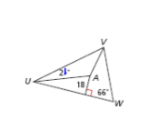

The distance from A to UV. ________ <WVA=_________

11) Find each measure.

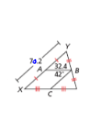

BC=_______ XZ=_______ XC=_______ <YXZ=_______

12) PQ is a midsegment of ▲RST. What is the length of RT?

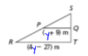

SECTION THREE – PROOF. You may use 2-column format for all or you may use paragraph proof. Your choice.

13) Prove that the < bisector of an equilateral triangle is also the median.

14) Prove that an obtuse triangle must have 2 acute angles. (Indirect is what I recommend.)