For each pair of triangles, tell which postulates, if any, make the triangles congruent.

1. ΔABC ≅ ΔEFD ______________ 2. ΔABC ≅ ΔCDA ______________
C
A
D
B
C
A
B
D
F
E

3. ΔABC ≅ ΔEFD ______________ 4. ΔADC ≅ ΔBDC ______________
A
B
D
C
A
C
B
D
F
E

5. ΔMAD ≅ ΔMBC ______________ 6. ΔABE ≅ ΔCDE ______________
A
B
E
C
D
D
A
C
B
M

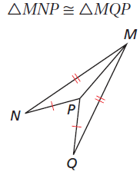
7. ΔACB ≅ ΔADB ______________ 8. ______________
A
C
D
B

