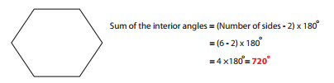
Find the Sum of interior angles for each polygon.


1. 2.



3. 4.

Answers
1. 720°

2. 1080°

3. 1440°

4. 1260°

