Tell whether the figure is a polygon and whether it is convex or concave
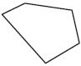
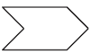

How many sides do each of the following polygons have?
4. Hexagon
5. Dodecagon
6. Pentagon
Answer the following questions.

7. If a regular Hexagon has a side length of x+3 what is the perimeter?
8. If an isosceles triangle has a base of y+1 and sides of 2x-3 and 4x-7 find x.
9. Name something that is shaped like a pentagon then draw a picture of it.

10. What is the angle measure of each interior angle of an equiangular triangle?

For Exercises 11–14, draw the regular polygons labeling sides and angles.
11. Octagon 12. Dodecagon

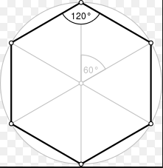
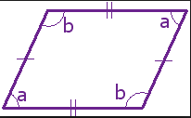
13. Parallelogram 14. Hexagon

ANSWERS
Tell whether the figure is a polygon and whether it is convex or concave
- POLYGON, CONVEX
- POLYGON, CONVEX
- POLYGON, CONCAVE

How many sides do each of the following polygons have?
4. Hexagon 6
5. Dodecagon 12
6. Pentagon 5
Answer the following questions.

7. If a regular Hexagon has a side length of x+3 what is the perimeter? X = 3
8. If an isosceles triangle has a base of y+1 and sides of 2x-3 and 4x-7 find x. X = 2
9. Name something that is shaped like a pentagon then draw a picture of it.
THE PENTAGON

10. What is the angle measure of each interior angle of an equiangular triangle?

60°

For Exercises 11–14, draw the regular polygons labeling sides and angles.
11. Octagon 12. Dodecagon
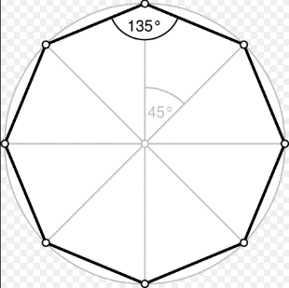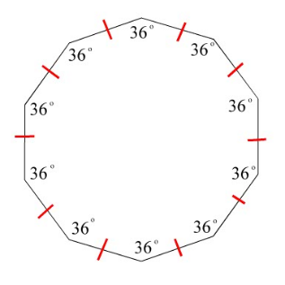

13. Parallelogram 14. Hexagon

