Adjacent Angles and Vertical Angles
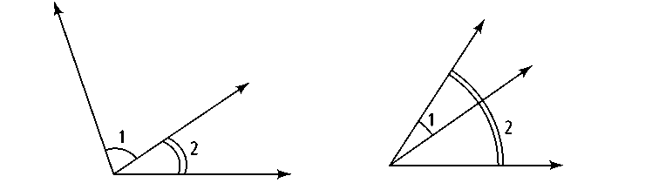
Adjacent means “next to.” Angles are adjacent if they lie next to each other. In other words, the angles have the same vertex and they share a side without overlapping.

Adjacent Angles Overlapping Angles
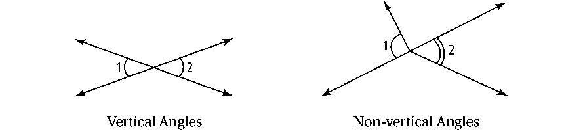
Vertical means “related to the vertex.” So, angles are vertical if they share a vertex, but not just any vertex. They share a vertex formed by the intersection of two straight lines. Vertical angles are always congruent.

Vertical Angles Non-Vertical Angles
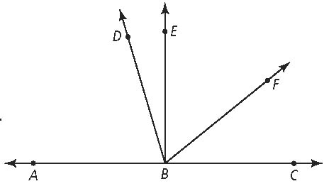
Exercises
1. Use the diagram at the right.
a. Name an angle that is adjacent to ∠ABE.
b. Name an angle that overlaps ∠ABE.

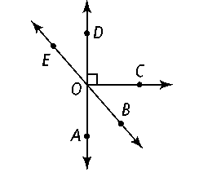
2. Use the diagram at the right.
a. Mark ∠DOE and its vertical angle as congruent angles.
b. Mark ∠AOE and its vertical angle as congruent angle

