Name:____________________________________________ Date:________________ Class:_____________

**Short Quiz / Exit Slip: Measuring Angles**

1. Which of the following is NOT one of the undefined terms of geometry?

**A** angle **B** line **C** point **D** plane

1. Look at the figure below:

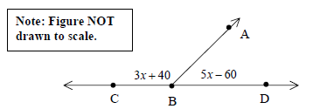

Angles ABC and ABD form a linear pair. What is the value of *x*?

**A** 12.5 **B** 13.75 **C** 25 **D** 50

1. Look at the figure below:

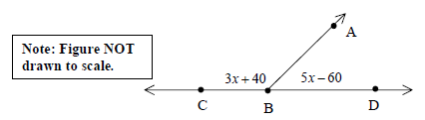

Angles ABD and ABC form a linear pair. What is the measure of angle ABD?

**A** 2.5° **B** 8.75° **C** 40° **D** 65°

1. Look at the drawing below:

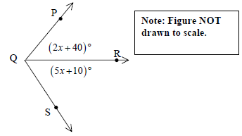

If ** is the angle bisector of ∠*PQS* , what is the measure, in degrees, of ∠*PQS* ?

1. Look at the drawing below:

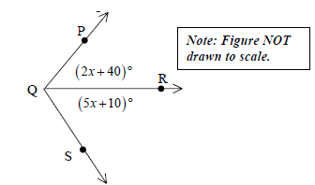

If  is the angle bisector of ∠*PQS* , what is the measure, in degrees, of∠*PQS* ?