- Which of the following is NOT one of the undefined terms of geometry?
A angle B line C point D plane

- Look at the figure below:
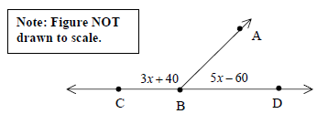
Angles ABC and ABD form a linear pair. What is the value of x?
A 12.5 B 13.75 C 25 D 50

- Look at the figure below:
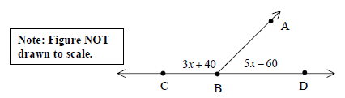

Angles ABD and ABC form a linear pair. What is the measure of angle ABD?
A 2.5° B 8.75° C 40° D 65°
- Look at the drawing below:

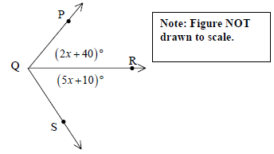
If is the angle bisector of ∠PQS , what is the measure, in degrees, of ∠PQS ?

- Look at the drawing below:
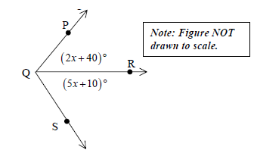
If is the angle bisector of ∠PQS , what is the measure, in degrees, of∠PQS ?

ANSWERS

- Which of the following is NOT one of the undefined terms of geometry?
A angle B line C point D plane

- Look at the figure below:
Angles ABC and ABD form a linear pair. What is the value of x?
A 12.5 B 13.75 C 25 D 50

- Look at the figure below:

Angles ABD and ABC form a linear pair. What is the measure of angle ABD?
A 2.5° B 8.75° C 40° D 65°

- Look at the drawing below:

If is the angle bisector of ∠PQS , what is the measure, in degrees, of ∠PQS ? 120°

- Look at the drawing below:
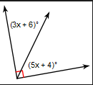
Find the value of X and then find the following angles.
X = 10 3x + 6 = 36° 5x + 4 = 54°

