Goal: To measure angles using a protractor.

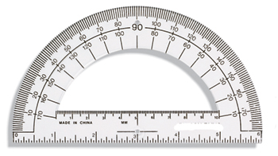

When using a protractor, you must use it correctly. What are the two things you need to do when using a protractor?

1. _______________________________________________________________________________

2. _______________________________________________________________________________
ANSWERS
Goal: To measure angles using a protractor.

When using a protractor, you must use it correctly. What are the two things you need to do when using a protractor?

1. PLACE THE ORIGIN OVER THE VERTEX OF THE ANGLE.

2. ROTATE THE PROTRACTOR SO THAT ONE LEG IS ALIGNED WITH THE BASELINE OF THE PROTRACTOR

