Name:_____________________________ Teacher:_______________________ Date:_______________
Measuring Angles Assignment Part 2

Goal: To measure angles using a protractor.

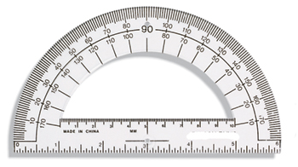

When using a protractor, you must use it correctly. What are the two things you need to do when using a protractor?

1. _______________________________________________________________________________

2. _______________________________________________________________________________

