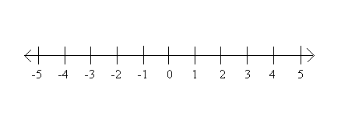
E
D
C
B
A
.
.
.
.
.
For 1 and 2 find the length of each segment. Tell whether the segments are congruent.

1. and 2. and

3. Using the number line above, find the midpoint of.

4. Find PD if the coordinate of P is -7 and the coordinate of D is -1.

5. Find SK if the coordinate of S is 17 and the coordinate of K is -5

6. Find the coordinate of B if AB = 8 and the coordinate of A is -2.

7. Find the coordinate of X if XY = 1 and the coordinate of Y is 0.

In the diagram of collinear points, GK = 24, HJ = 10, and GH=HI=IJ. Find each length.

8. HI 9. JK 10. IG 11. IK

ANSWERS
E
D
C
B
A
.
.
.
.
.
For 1 and 2 find the length of each segment. Tell whether the segments are congruent.

1. and 2. and

NO YES

3. Using the number line above, find the midpoint of.

-2 POINT C

4. Find PD if the coordinate of P is -7 and the coordinate of D is -1. 6

5. Find SK if the coordinate of S is 17 and the coordinate of K is -5 22

6. Find the coordinate of B if AB = 8 and the coordinate of A is -2. 10

7. Find the coordinate of X if XY = 1 and the coordinate of Y is 0. 1

In the diagram of collinear points, GK = 24, HJ = 10, and GH=HI=IJ. Find each length.

8. HI 9. JK 10. IG 11. IK
5 9 10 14

