Use the figure below to answer questions 1-6.
1. Name the plane with 3 letters: __________

2. AC intersects the plane at what point: ____________
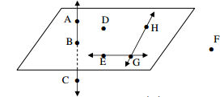
3. HG and GE intersect at what point? _______

4. Name 3 collinear points: ________________

5. Name a point NOT on the plane: ___________

6. Are points F, D, E and B coplanar? __________
Use the figure at the right to answer the following.
7. How many planes are there in the figure? ___________
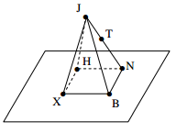
8. How many planes contain H? __________

9. Name three collinear points: ___________

10. Name two points not on the Plane XBN: ___________

11. Name four points that are coplanar: _____________

12. Name a line that does NOT contain J: _____________

13. Name three non-collinear points: _________

Use the figure below to answer questions 1-6. ANSWER KEY
1. Name the plane with 3 letters: _Any letters but C or F_________

2. AC intersects the plane at what point: _B___________
3. HG and GE intersect at what point? _G______

4. Name 3 collinear points: _ABC_______________

5. Name a point NOT on the plane: _F or C__________

6. Are points F, D, E and B coplanar? _NO_________
Use the figure at the right to answer the following.
7. How many planes are there in the figure? _5__________
8. How many planes contain H? _3_________

9. Name three collinear points: _JTN__________

10. Name two points not on the Plane XBN: _JT__________

11. Name four points that are coplanar: _HNBX____________

12. Name a line that does NOT contain J: _HN, NB, BX, HX____________

13. Name three non-collinear points: _Any Combination but JTN________

