Name:_____________________________Teacher:_______________________ Date:_______________
GEOMETRY COURSE
Pre-Test | Post-Test

Answers:
1. $\sqrt{10}$
2. (1,1)
3. An angle bisector is a line segment that divides the angle into two equal parts.
4. Perpendicular (Since the product of the slopes of two lines is -1 i.e. 5 x (-1/5) = $-$1 )
5. Neither (Since the slopes of the two lines are neither equal nor their product is equal to $-$1)
6. Point slope form: y + 2 = 7(x $–$ 5) ; Slope-intercept form: y = 7x $–$ 37
7. Point slope form: y - 6 = $\frac{1}{3}$(x $+$ 1) ; Slope-intercept form: 3y = x $+$ 19
8. 22.5°, 67.5°
9. 36°, 144°
10. <1 and <6, <2 and <5, <3 and <8, <4 and <7, <9 and <11, <10 and <12
11. Transitive property of line segments
12. Equality property of angles
13. Since <1 and <2 are supplementary angles, and <3 and <4 are supplementary angles, and <2 and <4 are congruent, so <1 must be equal to <3 so that the sum of angles remains 180°.
14. <1 $≅$ <5, <3 $≅$ <7, <4 $≅$ <8, <2 $≅$ <6
15.
Statements | Reasons
1. <5 $≅$ <7 | 1. Corresponding angles are congruent
2. <4 $≅$ <7 | 2. Vertical angles are congruent
3. <4 $≅$ <5 | 3. Transitive property of angles
16. Perimeter = 36.44
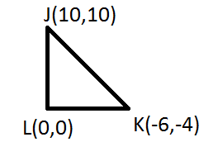
17. Perimeter = 16.8
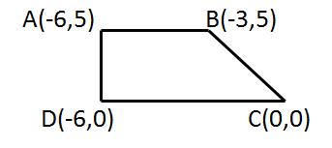
18. Area = 22
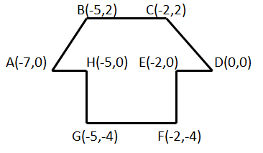
19. 29.31cm³
20. 301.44mm³
21. b < d < a < e < c
22. 60°
23. m<H < m<F < m<G
24. No, because no combination of lengths can satisfy the Pythagorean law of right-angled triangles.
25. $7\sqrt{2}$
26. a = 10m, b = $10\sqrt{3}$
27. Triangles are similar, since the ratio of the three corresponding sides is the same i.e. ¾
28. The ratio of line segment EF to line segment FG is equal to the ratio of line segment EI to line segment IH i.e. 5/4.
Theorem used: If a line is parallel to one side of a triangle and intersects the other two sides of the triangle, the line divides these two sides proportionally.
29. Using SAS (side angle side) theorem, both triangles have one same angle i.e. 90 degrees and the ratio of sides including this angle is same i.e. 2.
30. 23.6 ft.
31. R’(-5,6), S’(-3,10), T’(-2,2)
32. D’(7,1), E’(7,8), F’(-1,8), G(-1,1)
33. 12/13

34. a) 3/5
b) 4/5
c) 3/4
35. 1980°
36. 5
37. 60°
38. 75°
39. 75°
40. 25°

