- The ___ net ____ of a 3-D shape is a 2-D shape which can be folded to get the 3-D shape.

- Number all the faces of this net and fold it in a sequence. Which 3-D shape is made from this net?
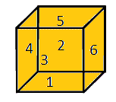
It is the net of a cube
- A two dimensional shape having two circular and one rectangular face is the net of a
_________ Cylinder ________.
- How many triangular shapes does the net of a prism have? Draw the net of a prism.
A prism has 2 triangular shapes in its net
