- The __________ of a 3-D shape is a 2-D shape which can be folded to get the 3-D shape.

- Number all the faces of this net and fold it in a sequence. Which 3-D shape is made from this net?
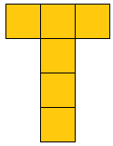
- A two dimensional shape having two circular and one rectangular face is the net of a
_________________.
- How many triangular shapes does the net of a prism have? Draw the net of a prism.

