Part A Instructions: Choose the option that completes the sentence or answers the question.

- A Cube has ________________________ squares in its net.
  - 4
  - 6
  - 8
  - 12

- A prism has ________________________ triangles in its net.
  - 2
  - 3
  - 4
  - 5

- All of the following shapes can be made into a net EXCEPT:
  - Cube
  - Triangular Pyramid
  - Cylinder
  - Sphere

- Which of the following is correct about the net of a 3-D shape?
  - It is a way of representing a 3-D figure from a corner view showing 3 sides with the angles between the 3 axes equal.
  - It is a way of showing a 3-D object in 2-D by showing a front, top, & right side view of the object.
  - It shows the base of each figure & the height of each part with a number.
  - It is a two-dimensional shape that you can fold to form a three-dimensional shape.

Part B Instructions: Draw the 3-D shape.
- Draw the 3-D shape that has the net shown below?

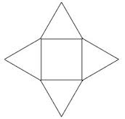

Draw 3-D shape here

Answers: Part A Instructions: Choose the option that completes the sentence or answers the question.

- A Cube has ________________________ squares in its net.
  - 4
  - 6
  - 8
  - 12

- A prism has ________________________ triangles in its net.
  - 2
  - 3
  - 4
  - 5

- All of the following shapes can be made into a net EXCEPT:
  - Cube
  - Triangular Pyramid
  - Cylinder
  - Sphere

- Which of the following is correct about the net of a 3-D shape?
  - It is a way of representing a 3-D figure from a corner view showing 3 sides with the angles between the 3 axes equal.
  - It is a way of showing a 3-D object in 2-D by showing a front, top, & right side view of the object.
  - It shows the base of each figure & the height of each part with a number.
  - It is a two-dimensional shape that you can fold to form a three-dimensional shape.

Part B Instructions: Draw the 3-D shape.
- Draw the 3-D shape that has the net shown below?

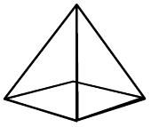
Draw 3-D shape here

