Write the name and the number of geometrical shapes in the net of each 3-D shape given below.
- Cube
__________________________________________________________
- Cone
_________________________________________________________
- Cylinder
________________________________________________________
- Prism
_________________________________________________________
Choose the correct answer in each question.
- The base of a cone is always a ___________?
a. Triangle b. Rectangle c. Circle d. Hyperbola
- Which of these 3-D shapes has a triangular base?
a. Cylinder b. Cone c. Cube d. Prism

Match the columns correctly. Match each 3-D shape with its net.
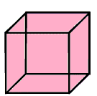
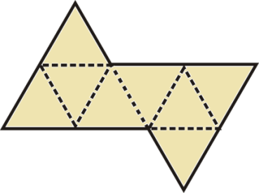
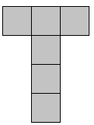
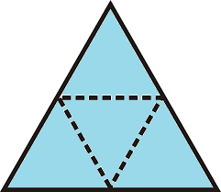

Write the name and the number of geometrical shapes in the net of each 3-D shape given below.
- Cube
____________________6 Square faces________________________
- Cone
____1 circle, 2 lines joining at a common point and extending from the circle____
- Cylinder
_____________1 rectangle, 2 circles__________________________
- Prism
_____________3 rectangles, 2 triangles_____________________
Choose the correct answer in each question.
- The base of a cone is always a ___________?
a. Triangle b. Rectangle c. Circle d. Hyperbola
- Which of these 3-D shapes has a triangular base?
a. Cylinder b. Cone c. Cube d. Prism

Match the columns correctly. Match each 3-D shape with its net.

