Name:_____________________________Teacher:_______________________ Date:_______________

GEOMETRY COURSE
Pre-Test | Post-Test

Calculate the distance between each given pair of points. Reduce the radical.
- and
Determine the midpoint of a line segment with each set of given endpoints.
- and
Vocabulary - Define the term in your own words.
- angle bisector
Determine whether each pair of lines are parallel, perpendicular, or neither. Explain your reasoning.
- line r:
line s: 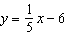
- line n:
line m:
Determine an equation for the parallel line described. Write your answer in both point-slope form and slope-intercept form.
- What is the equation of a line parallel to that passes through ?
Determine an equation for the perpendicular line described. Write your answer in both point-slope form and slope-intercept form.
- What is the equation of a line perpendicular to that passes through ?
Use the given information to determine the measures of the angles in each pair.
- The measure of the complement of an angle is three times the measure of the angle. What is the measure of each angle?
- The measure of the supplement of an angle is one fourth the measure of the angle. What is the measure of each angle?

Name each pair of vertical angles.
- 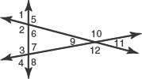
Identify the property demonstrated in each example.
Write the given proof as the indicated proof.
- Write the two-column proof of the Congruent Supplement Theorem as a paragraph proof.

Given: is supplementary to , is supplementary to , and

Prove:

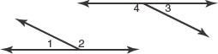

Statements Reasons
1. is supplementary to | 1. Given
2. is supplementary to | 2. Given
3. | 3. Given
4. | 4. Definition of congruent angles
5. | 5.
6. | 6. Definition of supplementary angles
7. | 7. Substitution Property
8. | 8.
9. | 9. Subtraction Property of Equality
10. | 10. Definition of congruent angles

Write congruence statements for the pairs of corresponding angles in each figure.
- 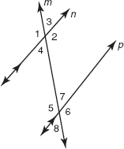
Prove each statement using the indicated type of proof.
- Use a two-column proof to prove the Alternate Exterior Angles Theorem. In your proof, use the following information and refer to the diagram.

Given: t is a transversal

Prove:

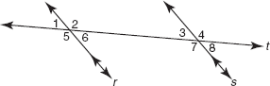
Translate the given triangle such that one vertex of the image is located at the origin and label the vertices of the translated image. Then, determine its perimeter. Round your answer to the nearest hundredth, if necessary.
- triangle JKL

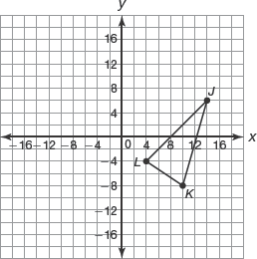

Translate the given trapezoid such that one vertex of the image is located at the origin and label the vertices of the translated image. Then, determine the perimeter or area. Round your answer to the nearest hundredth, if necessary.
- perimeter of trapezoid ABCD

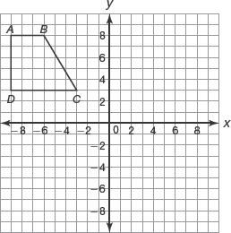
Translate the given composite figure such that one vertex of the image is located at the origin and label the vertices of the translated image. Then, determine the perimeter or area. Round your answer to the nearest hundredth, if necessary.
- area of figure ABCDEFGH

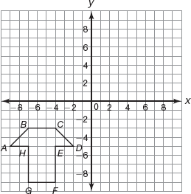

Calculate the volume of each cone. Use 3.14 for .
- 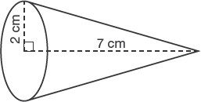
Calculate the volume of each cylinder. Use .
- 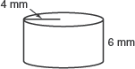
List the side lengths from shortest to longest for each diagram.
- 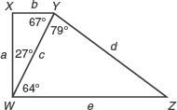
Solve for x in each diagram.
- 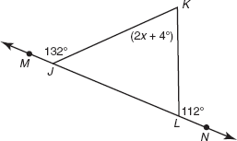
Without measuring the angles, list the angles of each triangle in order from least to greatest measure.
- 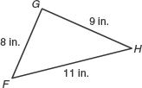

Determine whether it is possible to form a triangle using each set of segments with the given measurements. Explain your reasoning.
- 4 meters, 5.1 meters, 12.5 meters
Determine the length of the hypotenuse of each triangle.
Write your answer as a radical in simplest form.
- 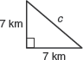
Given the length of the hypotenuse of a triangle, determine the lengths of the two legs. Write your answers as radicals in simplest form.
- 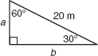
Determine whether each pair of triangles is similar. Explain your reasoning.
- 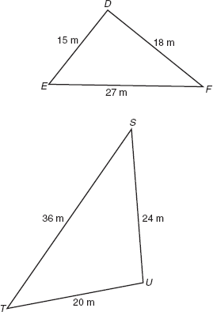

Use the diagram and given information to write a statement that can be justified using the Proportional Segments Theorem, Triangle Proportionality Theorem, or its Converse. State the theorem used.
- 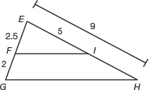
Explain how you know that each pair of triangles are similar.
- 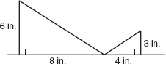
Use indirect measurement to calculate the missing distance.
- What is the height of the palm tree?
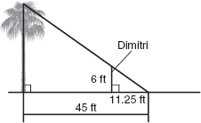
Determine the coordinates of each translated image without graphing.
- The vertices of triangle RST are R (0, 3), S (2, 7), and . Translate the triangle 5 units to the left and 3 units up to form triangle .
Determine the coordinates of each reflected image without graphing.
- The vertices of rectangle DEFG are , and G (1, 1). Reflect the rectangle over the y-axis to form rectangle .

Determine the ratio 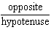 using as the reference angle in each triangle. Write your answers as fractions in simplest form.
- 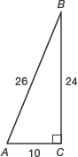
Determine the ratios , 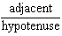, and using as the reference angle in each triangle. Write your answers as fractions in simplest form.
- 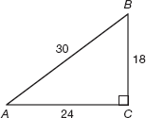

Calculate the sum of the interior angle measures of each polygon.
- A polygon has 13 sides
Calculate the number of sides for the polygon.
- The measure of each angle of a regular polygon is .
Determine the measure of the minor arc.
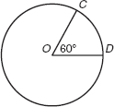

Determine the measure of each inscribed angle.

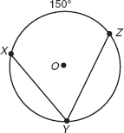
- Determine .





